Content Management training

Module BM01: Digital marketing

Case study

Please read carefully the below case studies provided by Single Grain.

Intuit Case Study

At Single Grain, we worked with the tax preparation software company Intuit to boost visibility via several common keywords in the industry.
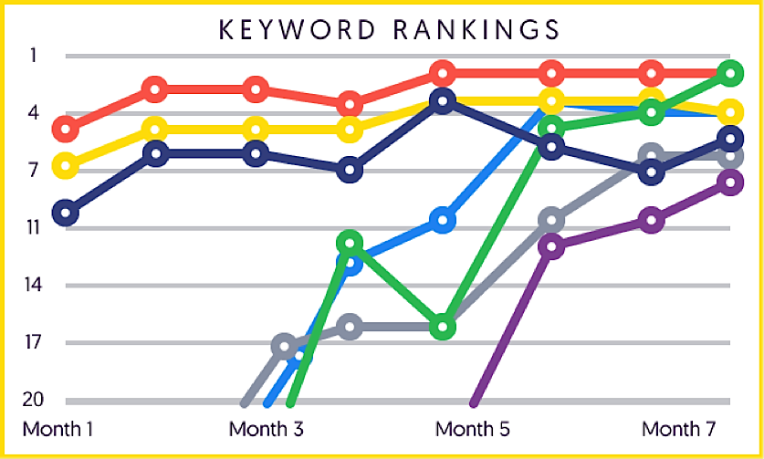
Source: Single Grain case studies

At the time, Intuit was adding on the Intuit Website Builder as part of their product portfolio. Based on their research, they found that their customers wanted simple tools for other aspects of their business as well, such as building their website.
The challenge for us was helping Intuit build visibility and become known for services outside of the main ones for which they are known. Plus there was some concern around their highly-specialized competitors like GoDaddy.
To solve that, we helped Intuit build visibility in organic search results. That meant building out content on the site to help position Intuit as a website-building solution.
Tactically, we used a mix of link-building techniques to help Intuit rank higher for relevant keywords in this space, and leveraged social media to connect with new users who had a high likelihood of being interested in Intuit’s new website building solution.

DisabledGo Case Study
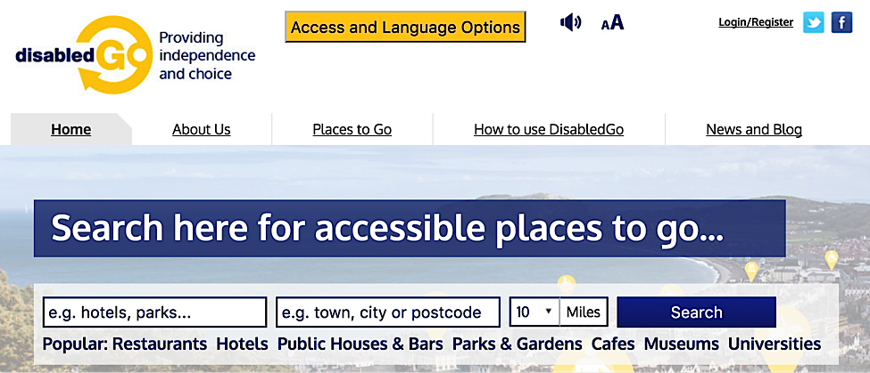

DisabledGo is an information provider for disabled people in the UK and Ireland. They provide information on 120,000+ places to go that are accessible (i.e. bars, parks, cafes, museums, etc).
Agency51 was tasked with helping DisabledGo execute an SEO migration strategy from an old platform to a new platform. The goal was to help DisabledGo acquire new customers while still retaining old ones.
They made sure that the move was as smooth as possible from an SEO point of view. For example, they implemented 301 redirects from old URLs to new ones across various forms of content. 301 redirects are ways to send readers and search engines to a different URL than the one that was requested by the server. This is a way to redirect users to a new page while still keeping 90-99% of the ranking power in search. They also transferred meta data (titles, descriptions, and tags) to the new site, set up Google webmaster tools, and set up a new sitemap.
The main goal of the project was to keep the site’s SEO alive throughout the migration, ensure that readers could still follow all the calls to action and navigate the site, and ultimately boost the number of new leads.
Agency51 helped DisabledGo boost their visitor numbers by 21% year over year. Because of the URL restructuring on the new platform, DisabledGo was able to rank higher than their competitors for keywords and phrases in their niche.

Harris Teeter Case Study
National grocery and pharmacy chain Harris Teeter approached us to help them boost visibility in social media.
The challenge in this case was the fact that there wasn’t much room for error. Grocery businesses have razor-thin profit margins, which means that every dime they invest into marketing needs to have a strong likelihood of producing a return. There’s not much to waste.
In addition to that, most grocery stores customers are located within a short distance from the grocery store of choice and don’t tend to venture further. These customers are also quite price sensitive.
We started off by testing a variety of different ad creatives, targeting segments, and placements. This helped us find a few combinations that delivered the most visibility for Harris Teeter in terms of social media fan base. Once the fan base was established, we started growing the engagement rates of posts.
The strategy we used to get in front of new customers was behavioral targeting. We implemented geographic targeting of ads, Lookalike Audiences, and oCPM (Optimized Cost Per Mille) bidding to stretch ad dollars the furthest.
On social media, images become “stale” faster than they do on other channels because of the speed of content consumption on social platforms, so we rotated fresh images more frequently.

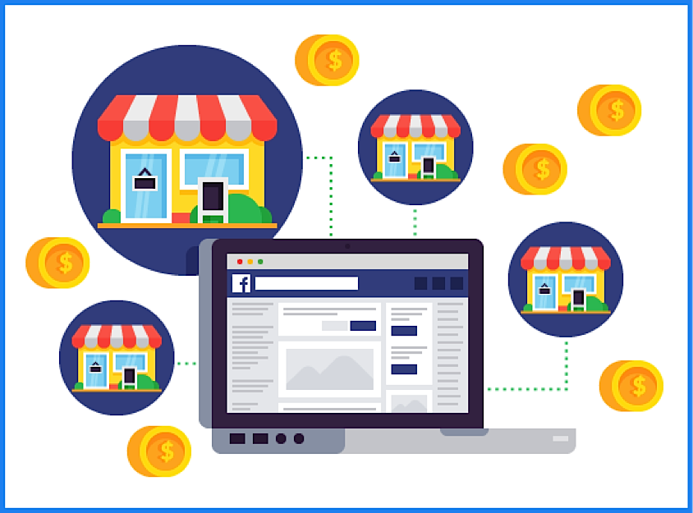
Source:Single Grain case studies

Now, let’s talk results.
We drove 15,000 people to Harris Teeter stores with a single campaign. We also doubled Facebook reach within six months and monetized new fans.
Just one coupon campaign drove more than 25,000 conversions during the holiday season. We also boosted post engagement by 400%.
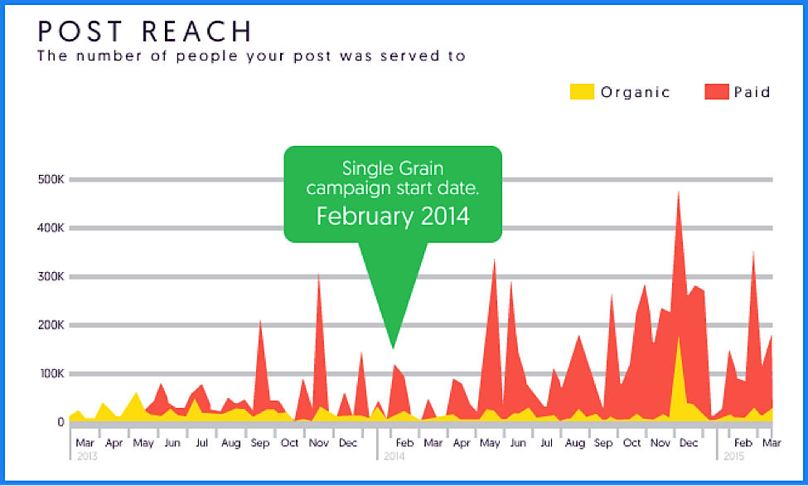
Source: Single Grain case studies

Laser Hair Removal Clinics Case Study
We also worked with a group of clinics that specialize in laser hair-removal. They hired us to turn more visitors into paying customers, or boost their conversion rate.
The challenge specific to the laser hair removal industry was the fact that high-profit margins led to increased competition. Some players in the market offer huge discounts and deals to try and make some quick cash.
From the customer’s perspective, laser hair removal is a sensitive topic, which means that they don’t want too many others to know that they’re looking for such services. That also means that it’s tough to get honest opinions about what works and what doesn’t.
Our approach started with conducting on-site and email surveys to capture as much information as possible from customers anonymously.
From there, we called our client’s business and experienced the process of laser hair removal from beginning to end from the point of view of a customer. This was extremely useful in generating ideas for improvements to test, as well as getting in the heads of potential customers.
Next, we dug into months and months of call center data to identify issues and prioritize them in order of how much each one affected the bottom line.
Our client received an ROI of over 475%. By targeting both desktop and mobile traffic, we were able to boost conversion rates across both successful user segments and segments that were previously underperforming.

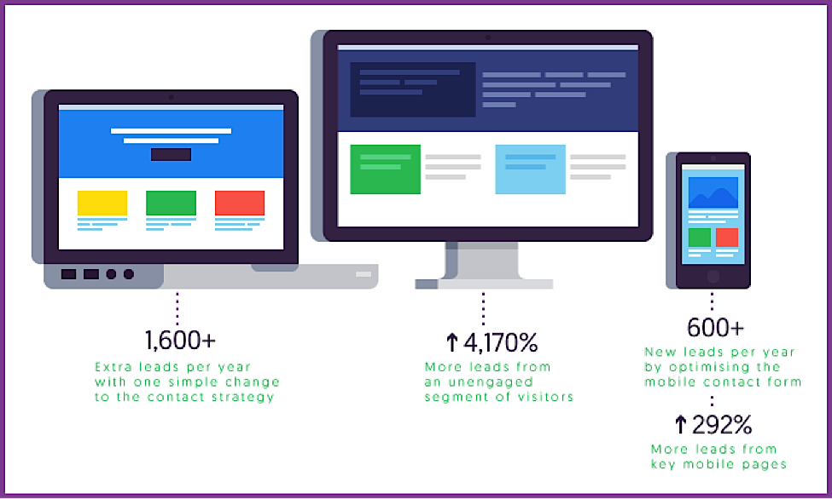
Source: Single Grain case studies

Hasbro Case Study
Hasbro is the brand behind a variety of children’s toys, such as Transformers, Star Wars, and The Avengers, and board games like Monopoly, Life, and Twister.
Amp Agency worked with Hasbro on managing both paid and organic search (SEO and SEM), creative online advertising, global analytics reporting, and analysis across all digital platforms (media, search, site, and social) for 25 Hasbro brands. They also figured out what was working and what wasn’t in their marketing spend to help improve ROI.
Their goals were the following:
- Gain more clarity on the impact of the main touch points that influence shoppers before, during, and after they engage with the brand online.
- Find patterns in engagements that correlate with conversions.
- Understand how investments in specific channels affect performance on other channels.

As you can tell, there’s a lot that went into this. To come up with some actionable insights for Hasbro, Amp put together this 3-part plan:
Step 1: Path to purchase analysis
One of the benefits of hiring a digital marketing agency is that they have specialized skills and team members that you may not have at your company. For example, Amp was able to put statisticians to work on Hasbro for more precise and high-level behavioral analyses.
Amp used third-party data to analyze browsing behavior of customers before they bought from the toy company. This way, they were able to better understand the factors that influence people to buy from a company like Hasbro.
By understanding the different aspects of the customer journey before transactions take place, Hasbro was able to get a much clearer picture as to where to put their marketing dollars.
Step 2: High-value behavior analysis
From there, Amp analyzed what customers did on Hasbro’s site. They analyzed the content that customers were engaging with, the content that preceded conversions, the content that reduced conversions, etc.
They used advanced predictive modeling techniques to analyze customer behavior across Hasbro sites to figure out exactly which types of content to create in order to guide customers through the purchase process more effectively.
This helped Hasbro understand what they needed to change about their content strategy, UX, and design to get the most conversions.
Step 3: Attribution analysis
Amp then used econometric modeling techniques to analyze media investment, which resulted in insights into the ROI of various marketing channels. This helped Hasbro see how all the marketing channels work together to help generate conversions on the site.
The results achieved by the agency here include better understanding for their client about the entire end-to-end customer journey. By knowing the behavioral patterns of customers before they interact with the Hasbro brand, the patterns of customer interactions with the site before making a purchase, and how all the marketing channels work together, Hasbro was able to optimize their marketing spend to get better ROI.
You don’t just have to hire an agency to handle SEO, paid advertising, or some specific marketing tactic. You could get massive benefits just by using an agency’s resources to analyze your business and find areas where you could boost your return on investment.

Your task: Try to assess the impact that the company made for their customers (Was the issue just a blip in their day and they barely noticed? Or, it was visible to them? Do they now have customers that went from loyal to disillusioned or the opposite?)

